Ledgewood Greenhouse Assembly Instruction
21 Foot- Wide 1.900” Bows

- Begin construction. Select the orientation for the greenhouse and establish the grades. The site should be nearly level across the width of the house and level or slightly inclined the length of the house. Stretch a high quality builder’s twine the length of one side plus two feet on each end. The string should be seven inches above the ground. The posts for one side will follow along the string to maintain a straight line. See Figure 1.
- Driving posts. The first post will be driven within two feet of one end of the string. Use the large bolt that is included and a hammer to set the post so the top drill hole is seven inches above the ground. The hole will line up with the string. Use the wooden spacing template to locate the next post. One notch in the template with fit around the first post and the second notch is where the second post will be located. Continue using the template to locate all of the posts in the first line. See figure 2.
- Locating the other line of posts. Locate the other line of posts. See page 4. The posts must be 21 feet apart from the outside of one side to the outside of the other line of posts. Make sure that the two sides are square to each other. Locate the two ends of the house and stretch the string the length of the house plus the two feet on each end. The string should be seven inches above the ground and level with the other side. Drive the first post where the corner was determined and use the template to space the remaining posts.
- Bow assembly. The long bow halves and the cap pieces are interchangeable. The short leg of the bow is the sidewall, the long leg is the rafter, It has a drill hole midway to attach the purlin. Assemble one bow by connecting two bow halves together with a cap piece in the middle. The 1.9” bow pieces slide over the cap to make the connection.(See step #5) The 2-½” long bolts are used to connect the three pieces together. Tighten the nuts only finger tight at this time. See figure 3. An insert between the post and bow is used to connect the post to the bow. The best way to attach the inserts is to bolt them to the bow before it is erected and slide the entire bow and insert into the post. The inserts are placed into the bow halves so that only one inch of pipe is below the bottom drill hole that goes into the post. See figure 7. After the purlins and corner braces are installed use a 5/16 by 2-½-inch bolt and nut to secure the insert to the bow. Two ¼ by 4-inch bolts are used to connect the baseboard to the post and insert.
- Two people can stand the completed bow up into position. Lift one side of the bow higher so the first side will drop onto the post. The second side must be compressed inward to insert it into the post. Continue installing bows for the rest of the house.
- Attaching purlin. The purlins are located in the rafter, the hip board attaches in the curve. The 2 purlins and ridgepole are connected to the underneath of the bows. The best way to attach the purlins is to install each side, then the ridgepole last. The ¼ x 4inch bolts are used to attach the purlins to the bows. See figure 4. Each purlin is taped together in a bundle and numbered in sequence (1,2,3,etc.) The purlin must not be mixed with other bundles. The number 1 piece is at one end of the house and the highest number is at the other end. Attach the first piece to the bows and then add the number 2 piece into the first and continue for all the pieces to make the full length. See figure 5. The drill holes every four feet will line up with each bow and all of the joints will fall in between bows and the pieces are connected using 2-inch bolts and nuts. The bolts should be only finger tight at this point.
- Corner brace installation. See page 5 for detailed installation instructions. The corner braces should all be attached in the same orientation. For example low to high from the end of the greenhouse toward the center. After the corner braces are attached all of the bolts in the frame should be tightened. The best way to do this is to strike the head of the bolt with a hammer to set it down into the bow. Be careful not to over tighten the nuts as the bolts might break or the threads could strip out.
- Crosstie installation (optional). See page 6 for detailed installation instructions. The crossties are an optional feature on all of the houses.
- Baseboard. The baseboard is attached to the outside of the greenhouse posts. Make sure that the joints in the lumber you use do not join at the posts. It is difficult to attach the baseboard to the post in that situation. Most installations use one 2 by 10-inch plank. The board is bolted to the ground posts using the holes that are predrilled and the 1/4x 4-inch bolts. Place the drill through the holes in the ground posts, drill through the board, insert the bolts and attach the nuts. See figure 6.
- End walls. See page 7 for an example of end wall construction. There are many choices for this step. The illustrated method is durable and fairly simple to complete.
- Polyethylene film installation. The most common glazing is either single or double layer poly film. The first step is to roll out the film either on the ground or down the ridge of the house. You must be willing to walk down the purlins to roll the poly down the ridge but it is the simplest approach. Leave the first layer folded up until you roll out the top layer, then unfold both layers. Make sure that the poly is square and even on both sides and ends. Using an extruded metal system or using wood strips and decking or roofing screws completes the attachment. Make sure that any system is very secure. If you are using wood strips the screws should be no further than 8 inches apart. “Star Drive” decking screws that are #9 by 2-inch work the best.

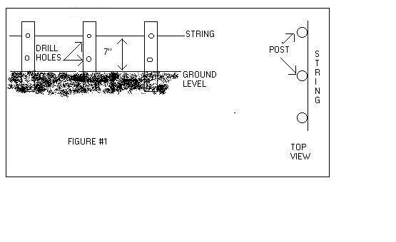
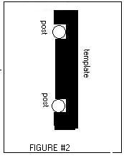
Assembly Diagrams
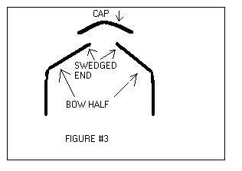
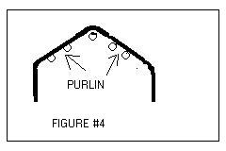
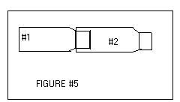
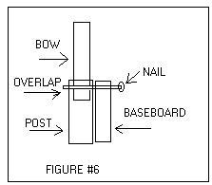

Ground Post Layout

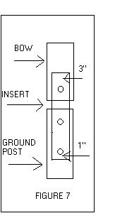Use Table 1 to determine the length of side “C” and the total length of sides “B”+”C. Attach the tape measure to the top outside of the first ground post and reel off the length “B+C”. Attach the tape at this distance to the top outside of the fourth post. Using a grade stake or other small diameter stake, pull the tape tight in both directions with the house width at the grade stake. Make sure the grade stake is plumb. The point of the stake will mark the first corner of the second line of ground posts. Repeat this procedure for the other end. Follow the directions in step 3 to complete the layout.
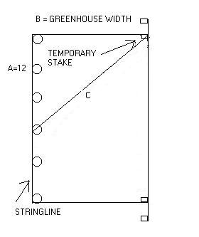

Table 1

Greenhouse Width | Length of “C” | Length of “B+C”
12 | 16’11.5” | 28’11.5”
14 | 18’5” | 32’5”
17 | 20’10” | 37’10”
21 | 24’2” | 45’2”
26 | 28’7.5” | 54’7.5”
28 | 30’5” | 58’5”
30 | 32’4” | 62’4”
Corner Brace Installation
Make certain the greenhouse is plumb before installing the corner braces. The corner braces should be installed before the baseboard.
The corner braces are installed in each corner of the greenhouse. Start at the second bow in from each end and continue to the fourth bow. The braces are installed between the purlins in five purlin greenhouses and above the purlin in three purlin greenhouses. See Picture 1 for installation location.
Two large clamps and 5/16x1-1/2”bolts are used to attach the two ends of the corner brace to the bow. The corner brace should be between the arms of the clamp. One large clamp and a small clamp are used to connect the middle of the corner brace to the bow. See Picture 2.
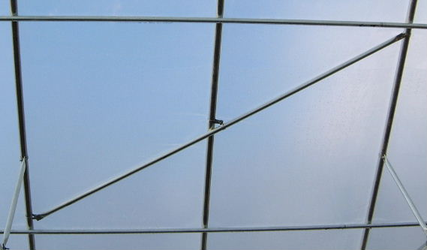
Picture 1

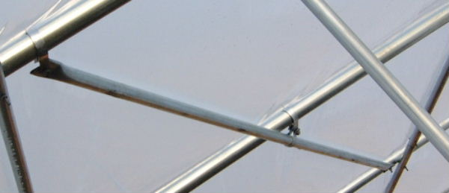
Picture 2
Cross Tie Installation
The cross- ties are attached to the bows with the clamps and 5/16x1-1/2”bolts that are included in the hardware package. The large clamps always go around the bow and the small clamps are used on the cross- tie or purlin. The cross- ties are attached to the even numbered bows or every bow.
The cross- ties are drilled in one corner at each end and the clamp goes around the bow. The clamp must be pulled open so that it will fit around the pipe and then closed so the bolt will be long enough to secure with a nut. The cross- tie fits between the arms of the clamp. Install the first cross- tie and level it from side to side. Now the remaining cross- tie locations can be marked with a permanent pen on the bow for faster installation and easier leveling. See photo #1.

The drops are attached to the ridge purlin and to the center of the cross- tie. A small clamp is placed around the ridgepole next to the bow and the drop is bolted inside the arms of the clamp. The bottom of the drop is attached to the cross- tie in the same way. The drops must be installed before the trusses. See photo #2Truss Installation. The large clamps go around the bow and the end of the truss with the drill hole in the center of the flattened section attaches to these clamps. The other end of the truss attaches to a clamp that is around the cross- tie. The hole in the flattened section must be turned closest to the cross- tie. See photo #2. Photo 1

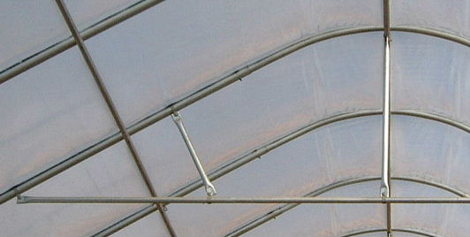
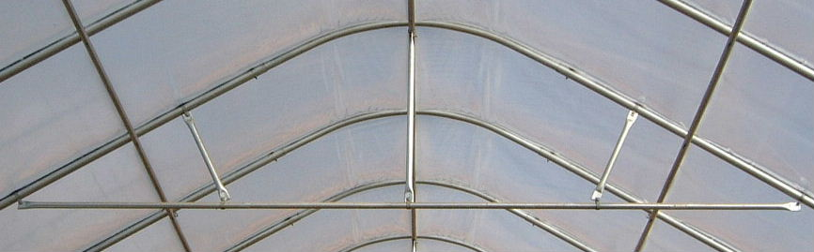Photo 2

End Wall Construction
A base plate or sill should be installed at ground level on each end. A two- layer sill works very well. The end wall may be constructed in any manner. The following photograph is one example. The 2”x4” or 2”x6”studs should be on two-foot centers. Find the middle of the end wall and measure two-foot centers toward each side. Stand an uncut stud in place, plumb the stud and mark its intersection with the bow. Cut the stud to length at the proper bevel. Toenail the stud in place at the bottom and then band it to the bow as shown in the diagram. Make sure the stud is flush to the outside of the bow. The banding should be screwed to the outside of the stud and then wrapped up over the bow and attached to the top of the stud on the inside. After all of the studs and plywood are in place, block in between the studs with pieces of two-inch wood as shown in the photograph. This provides a surface to screw the plywood to, as well as, a straight surface to attach the poly cover.
