1. A 2”x4” hip board must be attached to the greenhouse frame. There is a black line about 2” below the drill hole in the curve. The board will attach with the lower edge of the board touching the black line. Use the 4” carriage bolts and nuts to secure the board. You will also attach a strip of wood strapping to the upper edge of the hip board to act as a shelf to help shed snow.
2. The best strapping is 5/4”x6” pressure treated decking that is ripped into 1-3/4” strips. Pre-drill 5/32” holes 8 inches apart for the #10x 2-1/2” star drive decking screws and start all of the screws into the board before you roll out the poly. If you don’t pre-drill the strapping it won’t grip the poly tight and the poly will rip in the wind.
3. When you have completely finished construction of the entire frame including the end walls and doors it is time to put on the poly. You will have either one or two layers of poly. Make sure the IR poly is the inside layer in a two layer installation. Poly has an inside and an outside so make sure the poly is correct side out. It is important if you have roll up sides that the poly be centered and square on the frame, and the edges of both layers line up.
4. The easiest way to install the poly on our frames is to roll it down the ridgepole and then unfold it. The roll of poly with the RED Tape is the IR and it is the inside layer. The roll with the BLUE TAPE is the CL and it is the outer layer.
5. Select the IR roll of poly and align it so the poly will roll off the bottom of the roll. Take one of the long roll up pipes and slide the pipe through the cardboard core of the poly. Lift the roll up onto one end of the tunnel and place it so the center of the roll is on the ridgepole. Unroll about 18” of poly and pull it over the gable end. Attach the poly to the gable end with a short piece of wood strapping and a couple of decking screws. Now two people will climb out onto the tunnel with your feet on the purlin and one hand on the pipe that is through the poly roll and the other holding on to the bow. Now walk along the purlin and roll the poly the length of the tunnel, stopping a couple of times to make sure it is snug and straight. When you reach the other end, bring the poly over the gable end and attach it to the tunnel with another piece of strapping. If you have two layers you will repeat the steps and roll the second layer on top of the first. DO NOT UNFURL the first layer until both layers are installed. Now you can unfurl both layers, make sure they are square and comfortably taut and install the wood strapping. We attach one side first, check to make sure the poly is still aligned properly, install the second side and then attach the gable ends.
6. Inflation Fan. If you have two layers of poly you need to install the blower bracket before you finish securing the end where the fan is going to be located. See the instruction sheet in the bag with the bracket.
7. Roll up side. Attach the Tee handle to the #1 piece of roll up pipe with the ¼”x2” bolt and nut. The #2 pipe will slide onto the reduced end of #1 and connect the pieces together with one of the #12x3/4” Tek screws. Continue connecting pieces until the entire side is together. You will have a piece of pipe left over that is about 7’ long. This pipe slides through the Tee to lever the roll up side.
8. Attaching poly to the roll up pipe. The Tee handle should extend beyond the gable end of the tunnel about 18”. You will trim the poly so it ends just before the Tee handle or about 12”beyond the gable end. Lay the entire roll up pipe on top of the poly and use the black clips to attach the poly every 4’. You want to maintain an even edge so only wrap about three quarters of a wrap of poly onto the pipe before you attach the clips. The only way the roll up will work properly is if the poly is attached to the pipe evenly. The first and last clips must be at the respective ends of the poly.
9. Ropes. The last step is to attach ¼” UV protected polypropylene rope from the hip board to the baseboard every 8 feet along each side. Use the 5”eye bolts through the hip board and the 4” eye bolts through the base board. The eye bolts will be located 12 inches away from the bow. Make sure there is an eye bolt at each end of your tunnel. The rope will run vertically from the hip board to the baseboard. The bolt in the baseboard should be 3” from the top of the baseboard so the roll up can rest against the side of the baseboard to help seal out cold air.

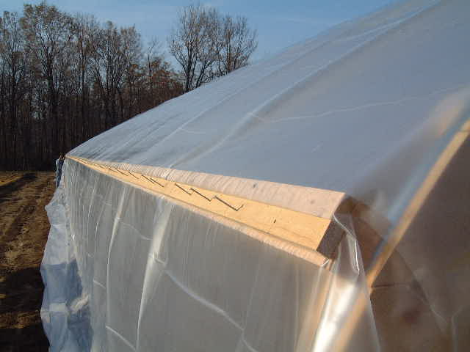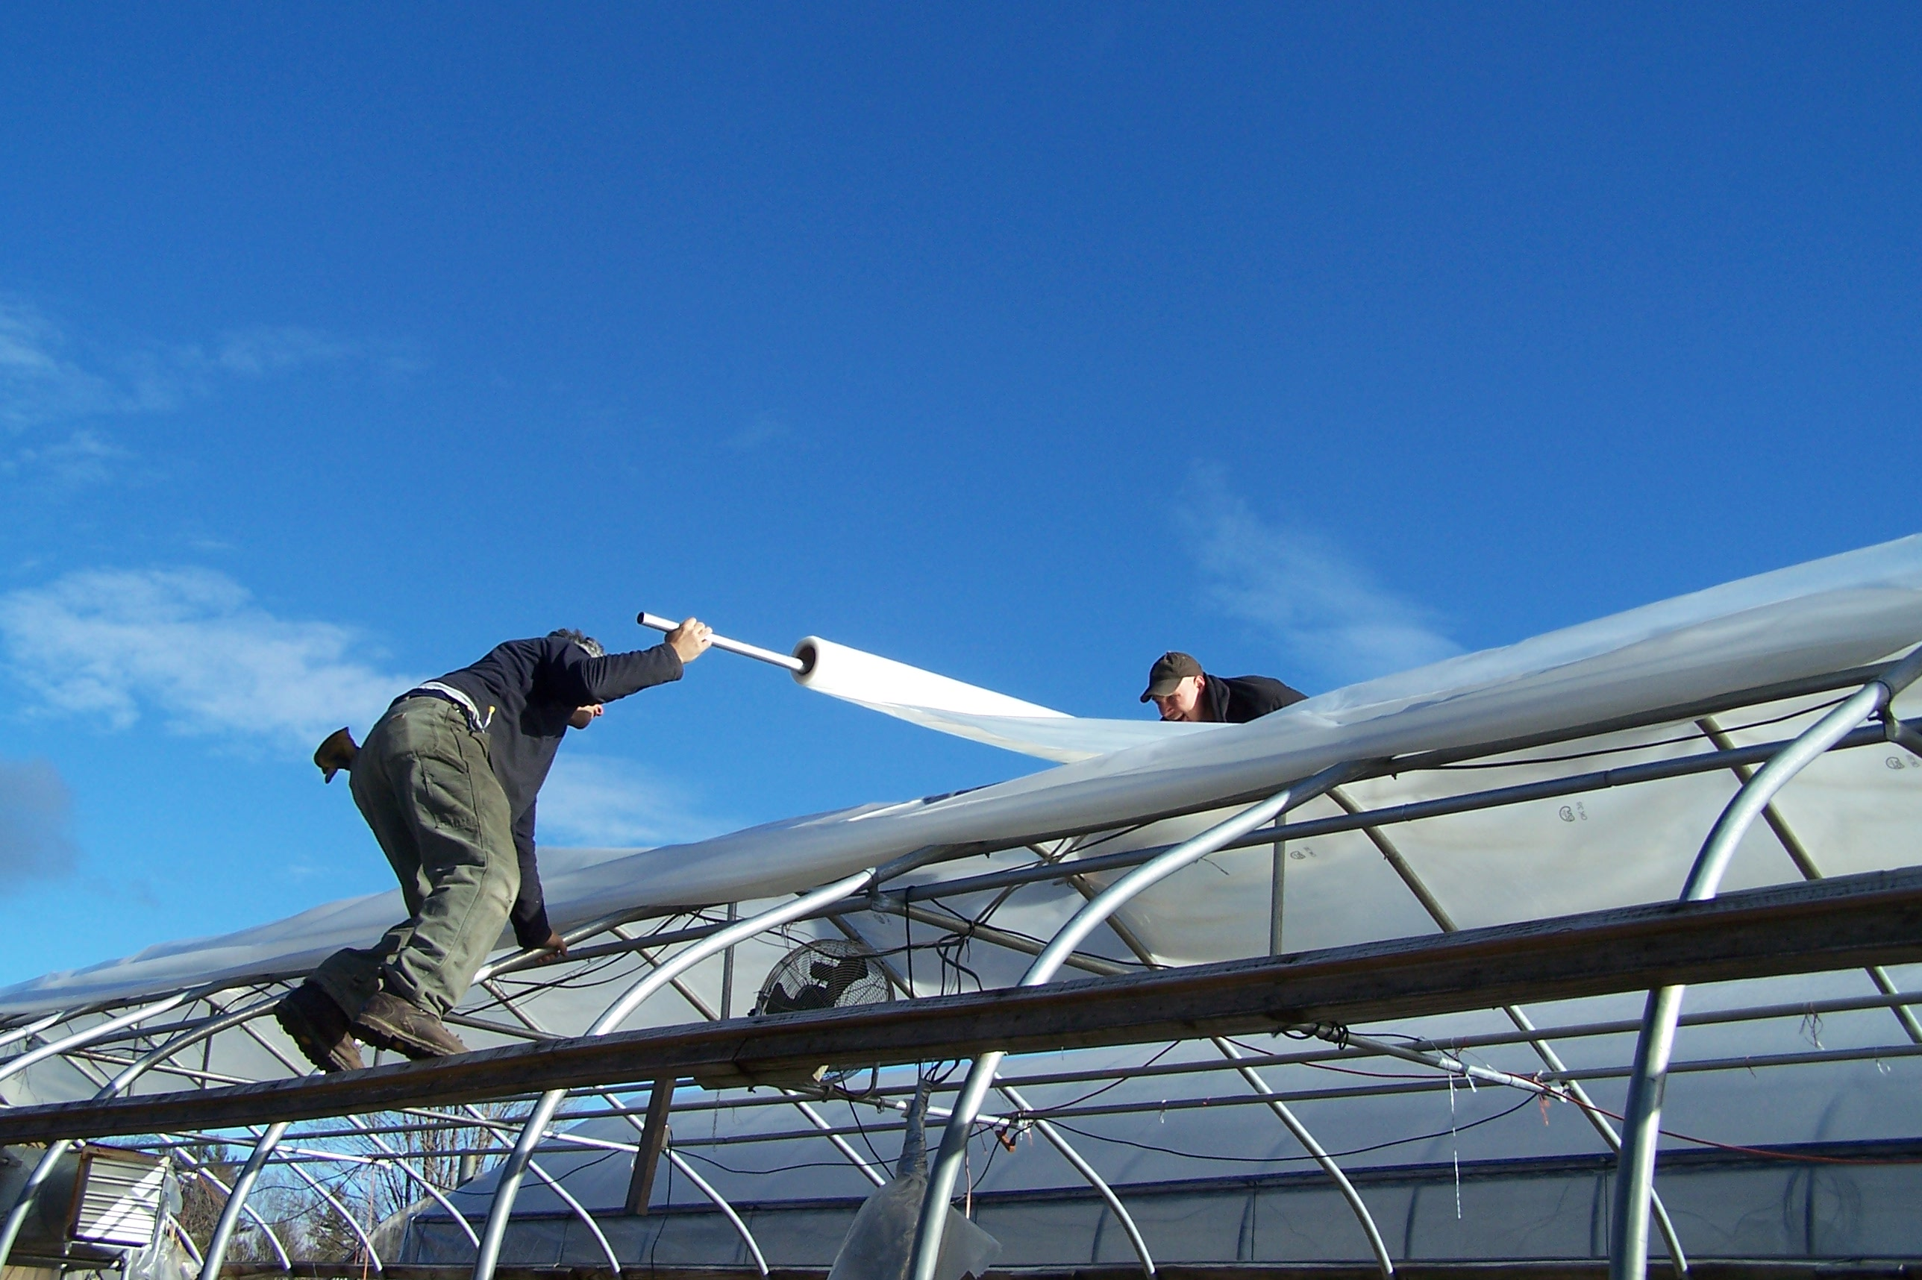 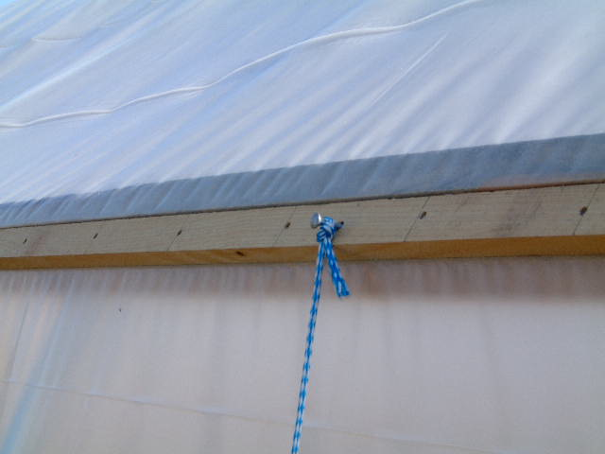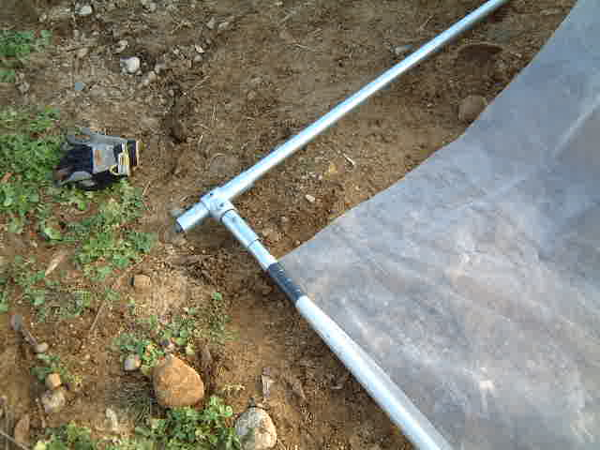

10.This instruction booklet is a guide for proper installation, but it is not the only system that may be used. Pipe frame greenhouses are vulnerable to weather extremes and you must take all precautions to insure the integrity of the greenhouse including closing them against high winds, adequately clearing snow from the sides and roof, and protecting the ground post foundation from being compromised. Please contact us if you have any questions about proper maintenance.